

<Title has to be in Each Word Starting with Capital Letters>
<Font: - Times New Roman Size: - 20 Effects: - Bold >

<Name with Initials>
（Reg. No.: XXXXXXXX）

A THESIS
SUBMITTED TO
SRI LANKA INSTITUTE OF INFORMATION TECHNOLOGY
IN PARTIAL FULFILMENT OF THE REQUIREMENTS
FOR THE DEGREE OF
MASTER OF SCIENCE IN INFORMATION TECHNOLOGY (TECHNOLOGY/MANAGEMENT/SYSTEM)

Dec 2026
I certify that I have read this thesis and that in my opinion it is fully adequate, in scope and in quality, as a thesis for the degree of Master of Science.

<<Prof/Dr/Mr/Mrs Supervisor’s name and surname>>

Approved for MSc. Research Project:

MSc in IT Programme Co-ordinator, SLIIT

Approved for MSc:

Head of Graduate Studies, FoC, SLIIT

DECLARATION

This is to certify that the work is entirely my own and not of any other person, unless explicitly acknowledged (including citation of published and unpublished sources). The work has not previously been submitted in any form to the Sri Lanka Institute of Information Technology or to any other institution for assessment for any other purpose.

Sign: ……<Signature of the student>........
<Student Name>

Date: ……………………………………..

ABSTRACT

Development of a Framework for Legal Reseasch using Text Mining

Student’s name and surname
MSc. in Information Technology
Supervisor: Prof/Dr/Mr/Mrs Supervisor’s name and surname
Dec 2026

Begin typing the body of the abstract here, 1.5 spacing throughout. Master’s theses Abstracts should be no more than about 250 words in length as a maximum. The purpose of the abstract is to provide a brief synopsis of your work, some background, key aim and some synthesis of your findings.

ACKNOWLEDGEMENT

While at Sri Lanka Institute Information Technology, I have benefited from having great advisors who seem to agree about very little. Dr. Koliya Pulasinghe was a great mentor, providing advice, constant constructive criticism of my ideas and writing, access to his web of contacts and friends, financial support, and the freedom to work on my own projects on his research account’s time.

This project could not have been completed without various groups providing financial assistance to fund fieldwork and the inclusion of questions on various surveys in 2024. I am especially grateful to the Mahapola Trust, which funded the fieldwork in 2024.

TABLE OF CONTENTS
DECLARATION iii
ABSTRACT iv
ACKNOWLEDGEMENT v
TABLE OF CONTENTS 6
List of Figures 7
List of Tables 8
Chapter 1 Formatting Basics 9
1.1 How to add the entries to the TOC 9
1.2 The Styles Added to the template 10
1.2.1 Sub of a Sub Section 11
Chapter 2 Page margins 12
2.1 First Page Margins 12
2.2 Margins of the rest of the Document 12
2.2.1 Right-side Margin 12
2.2.2 Top, Bottom and Left-side Margins 12
Chapter 3 Page Numbering 14
3.1 Page Numbers till the First Chapter 14
3.2 Page Numbers after First Chapter 14
Chapter 4 Applying Styles and Word Count 16
4.1 Styles 16
4.2 Word Count and Plagiarism check 16
How to add References (Bibliography) 17
Appendix 20
Appendix 1: Sub Category of Appendix 20

List of Figures

Figure 1.1 Adding Table of Contents 3
Figure 1.2 Styles 3
Figure 2.1 Page Layout 3
Figure 2.2 Set up the page margin 3
Figure 3.1 Page Break 3
Figure 3.2 Adding New Numbering System 3
Figure 3.3 Format Numbers 3
Figure 3.4 Change Options 3
Figure 4.1 Add a Reference 1 3
Figure 4.2 Create Source 3
Figure 4.3 Source Manager 3

List of Tables

Table 1.1 Style Table 3

Formatting Basics
For the Chapter Headings use SLIIT_Heading 1
Every Chapter should be started on a New Page.

How to add the entries to the TOC
For the sub section headings use SLIIT_Heading 2
When you are typing the body text you should select the Paragraphs Style.
You have to follow the below sequence to add records to TOC. You may refer the Fig.1.1 to add the content in to TOC.
For Lists as below use SLIIT_List Style You’ll have to restart the numbering at the beginning of each list.
- Select the Title you wanted to add to TOC
- Go to Reference Tab
- Click on Add Text
- Select the level that you want to add (Following the Correct Level is an advantage in editing the TOC)
- Finally click on Update Table


Figure 1.1 Adding Table of Contents

When editing the TOC, any change done to a particular level such as indentation will be added to all the latter texts in the TOC in same level. The TOC will have to be updated with every headings related to TOC is added.
Example: If heading section level 2 is indented with 0.2”; all the latter texts in heading section level 2 will be automatically indented with 0.2”.

The Styles Added to the template
When you create new chapter, section, or captions, you should select the relevant style Home > Styles.
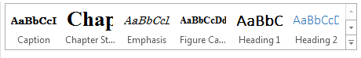
Figure 1.2 Styles
Use SLIIT_Caption style to adjust the Figures and captions.
Table 1.1 Style Table
Style Name | Description
Chapter Style | Format the SLIIT_Heading 1
Subsection 1 Style | Format the SLIIT_Heading 2
Figure Caption | Format the Figure Caption
Paragraphs | Format the SLIIT_PARA
You are free to add the figures to the document to any place within the given margins. Figure captions and the Table captions has to be as follows:
Figure <Chapter#>.<Figure#><space><Caption>
Note that the figure captions have to be at the bottom of the Figure left aligned. Figure captions has to be added as follows. You may refer Figure 1.2
- Right click on the figure
- Select insert caption
- Type the caption
- Select the label as figure
- Click OK
- Finally go the List of Figure page Reference tab Update Table
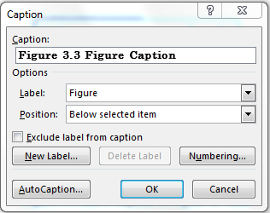
Figure 1.3 Add a Caption to Figure or Table
You may use the same method to add Table captions as well. However, note that the table captions should be at the top of the table.

Sub of a Sub Section
<SLIIT_Heading 3 – Level 3>
This is Subsection of a subsection. For the Paragraphs use SLIIT_PARA style.

Page margins
Page Size: - A4
Under this chapter the Page Margins will be explained.

First Page Margins
Set the page margins as 1 inch in every side.

Margins of the rest of the Document

Right-side Margin
Set the page right-side margin as 0.75 inches.

Top, Bottom and Left-side Margins
Set all the top, bottom and left-side margin as 1 inch.
Follow the guidelines to set page margin.
- Go to Page Layout
- Click the Margins tab and select Custom Margins
- Enter the relevant margin values to the correct field
- In the preview select whether need to apply for the selected section or to the whole document from Apply to drop down list.
- Then click OK to make the changes.


Figure 2.1 Page Layout

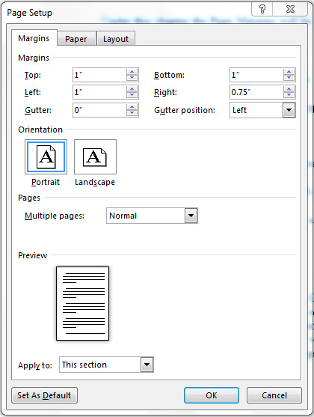
Figure 2.2 Set up the page margin

Page Numbering
How page Numbering of the Document should be will be explained here.

Page Numbers till the First Chapter
Add Roman Numbering System as Page Numbering System at the lower right side of the footer. Make sure to tick the “Different First Page” Option after selecting the Footer from the new menu appears in the top bar.

Page Numbers after First Chapter
After the page containing the TOC (Table of Content), add a page break.

Figure 3.1 Page Break
Then link it with the previous section and add new numbering system (Numeric) and in the dialog box select the option “Continue from the previous section”.
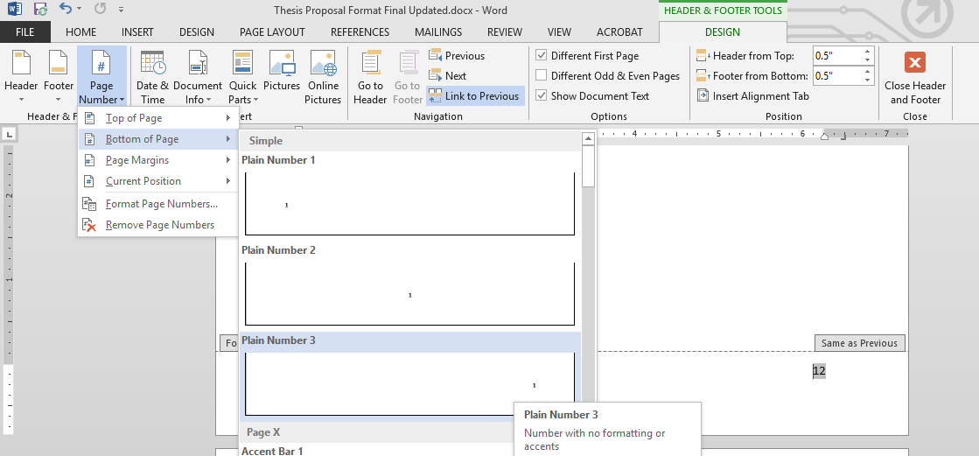
4- Right Click on the number
1
3
2
Figure 3.2 Adding New Numbering System

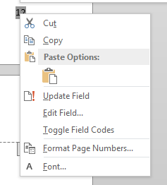
Figure 3.3 Format Numbers
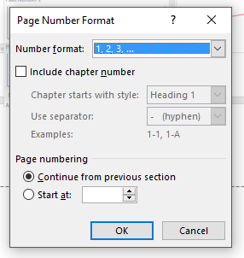
Figure 3.4 Change Options

Applying Styles and Word Count

Styles
When you are typing the body text you have to make sure that you selected the Paragraphs Style.
You have to follow the below sequence to add records to TOC.
- Select the Title you wanted to add to TOC
- Go to Reference Tab
- Click on Add Text
- Select the level that you want to add (Level 1)
- Finally click on Update Table

Word Count and Plagiarism check
Your Thesis should include a word count of 20,000 – 30,000.
Before you submit your Thesis, you need to check for Plagiarism using the Turnitin Software. Percentage should be less than 20%

How to add References (Bibliography)
When you add the Reference Page, make sure that you select the SLIIT-Page heading Style for the Heading.
Use IEEE format or APA-6 format.
You need to select the required Style in the Style drop down Menu in the below steps given.
You have to follow the below sequence to add a reference to TOC.
- Select the Title you wanted to add to TOC
- Go to Reference Tab
- Click on Add Text
- Select the level that you want to add (Level 1)
- Finally click on Update Table

Guidelines to add a Reference to the page

Figure 4.1 Add a Reference 1

- Go to Reference Tab
- Click on Insert Citation and click on add New Source
- Enter the relevant details
- Finally click OK
- Select Manage Sources Master List indicates the available added references.
- To add reference to the current list, select copy tab and click close.
- Select Reference Style from the drop down list.
- Click Bibliography drop down menu and select insert bibliography to display the references in the document.

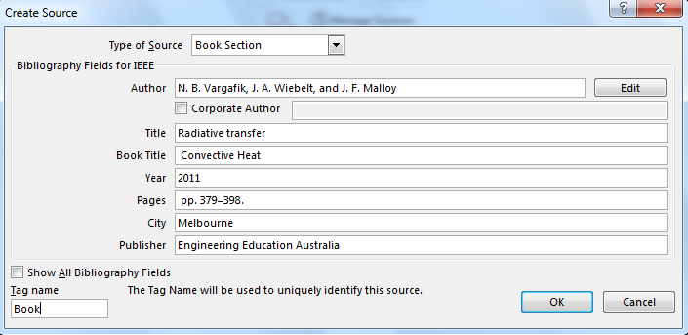
Figure 4.2 Create Source

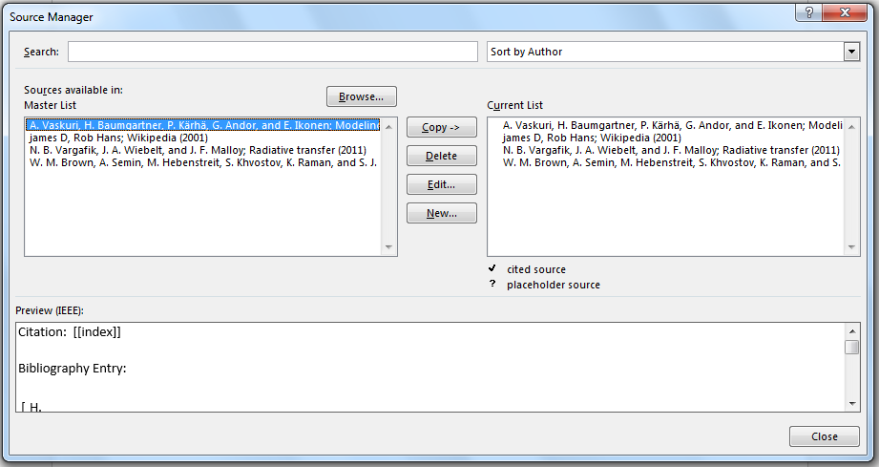
Figure 4.3 Source Manager

Sample Reference (IEEE Format)

[1] | W. M. Brown, A. Semin, M. Hebenstreit, S. Khvostov, K. Raman, and S. J. Plimpton, "Increasing molecular dynamics simulation rates with an 8-fold increase in electrical power efficiency," in SC '16 Proc. of the Int. Conf. for High Perf. Computing, Networking, Storage and Analysis, Salt Lake City, Utah, 2016.
[2] | A. Vaskuri, H. Baumgartner, P. Kärhä, G. Andor, and E. Ikonen, "Modeling the spectral shape of InGaAlP-based red light-emitting diodes," Journal of Applied Physics, vol. vol. 118, no. Jul. 2015, pp. pp. 203103-1–203103-7, 2015.
[3] | N. B. Vargafik, J. A. Wiebelt, and J. F. Malloy, "Radiative transfer," in Convective Heat, Melbourne, Engineering Education Australia, 2011, p. pp. 379–398.
[4] | james D, Rob Hans, "Science portal, Wikipedia," Wikimedia Foundation, 5 May 2001. [Online]. Available: https://en.wikipedia.org/wiki/Portal:Science. [Accessed 19 April 2018].

Appendix
Use the style SLIIT_Main for the above heading.
- Sub Category of Appendix
If your appendix is having sub-sections use SLIIT_Appendix Style for the sub heading.

